Aryey Leyb SVERDLOV, Hebrew name Aryey (or Aryeh) Leyb, also known as Ara Leib, b. est 1835 - 1845 in Lepel', Vitebsk, Byelorussia, d. est 1900 - 1905 in Lepel', Vitebsk, Byelorussia.

He married Rasha ONIKUL, birth name Raske Onukel or Onikul, Hebrew name Rachael, married est 1864 - 1872 in Lepel', Vitebsk, Byelorussia, (daughter of Yankel Moshe ONIKUL and Leah (Mrs) ONIKUL) b. 1835 in Lepel', Vitebsk, Byelorussia, d. 1904 in Lepel', Vitebsk, Byelorussia.

I. Louis (Nachum Leyb) SVERDLOVE, Hebrew name Nachum ben Aryeih (or Hirsch), also known as Leyb (Label) Leibe Swerdlow (on 1935 immigraation papers), b. 17-Oct-1875 in Lepel', Vitebsk, Byelorussia, immigrated est 1908 - 1912 to Montreal, Quebec, CAN, naturalized British Empire (Canada), immigrated 19-Aug-1935 to Enter U.S.A. at Rouses Point, NY from Montreal, naturalized 8-Apr-1938 in U. S. District Court, Eastern District, Brooklyn, NY, d. 7-Aug-1955 in Brooklyn, Kings, NY, buried in Montreal (Baron de Hirsch), Quebec, CAN, occupation Green grocer, resided 1935 at 498 Hindsdale Street, Brooklyn, NY, height 5' 8", weight 190#, military The Russo-Japanese War began on February 8, 1904.
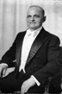
C:/BK6/DAVIDSON-DENBURG/Picture/Louie Sverdlove.thumb.jpg

He married (1) Sonia DAVIDSON, Hebrew name Sara, birth name Sonja, married name Sonja Swerdlow or Sonia Sverdlova, married abt 1900 in Lepel', Vitebsk, Byelorussia, (daughter of Chayim Hersh DAVIDSON and Channah Rashe FINKELSHTEIN) b. 1879 in Chashniki, Lepel', Vitebsk, Byelorussia, emigrated 16-May-1911, d. 21-Jul-1917 in Montreal, Quebec, CAN,¹ buried in Montreal (Baron de Hirsch), Quebec, CAN.¹

He married (2) Dora SEROTA, also known as Dvoira Sirota, married 10-Nov-1935 in Manhattan, New York, NY, b. 28-Aug-1892 in Kiev, Kiev, Ukraine, Russia, d. BEF 1986 in Montreal, Quebec, CAN.

A. Anna (Sora Hene) SVERDLOVE, also known as Sura Chenya (Sora-Genye), also known as Anna Swerdlov Ginsberg (Canadian Death Notice), nickname Annie,¹ (daughter of Louis (Nachum Leyb) SVERDLOVE and Sonia DAVIDSON) b. 23-Feb-1902 in Lepel', Vitebsk, Byelorussia, immigrated abt 1909 - 1911 to Montreal, Canada from Lepel', naturalized in Canada as British subject, immigrated Enter U.S.A. at Rouses Point, NY from Montreal, naturalized in New York as American citizen, d. 11-Feb-1940 in Brooklyn, Kings, NY, buried in Montreal (Baron de Hirsch), Quebec, CAN.^{,1}

She married Jacob B. "Jack" GINSBURG, also known as Ya'akov, married 29-Jan-1931 in Brooklyn, Kings, NY, b. 26-Mar-1901 in Manhattan, New York, NY ?, d. ?-Jun-1985 in Miami Beach, Dade, FL ?.

1. Irwin S. GINSBURG, b. 20-Dec-1931 in Brooklyn, Kings, NY, occupation mfr of drapery fabric, resided 1931 - 1955 at Parade Place, Brooklyn, NY, military abt 1951 - 1953 Korean War, occupation est 1955 -1958 electrician for Uncle Harry Sverdlove, occupation est 1958 - 1962 drapery fabric salesman, resided 1964 in New Brunswick, NJ, occupation 1964 - 1966 drapery fabric manufacturer, resided 1970 at 9 Yeoman Drive, Upper Saddle River, NJ 07458, resided 1990 at 266 River Road, Nyack, NY 10960, resided 1990 at 35 Park Avenue, New York, NY, occupation 1967 - 2004 fabric manufacturer.

He married (2) Madeline Dorothy "Madi" SPIEGEL, married 4-Dec-1960 in Manhattan, New York, NY, (daughter of Louis SPIEGEL) b. 28-Nov-1938 in Brooklyn, Kings, NY, d. abt 1995.

a. Anne Robin GINSBURG, also known as Chanah, (daughter of Irwin S. GINSBURG and Madeline Dorothy "Madi" SPIEGEL) b. 22-Sep-1961 in Brooklyn, Kings, NY ?, resided 1990 - 2004 at 13 Gainford Court, Olney, Maryland MD 20832-1660.

She married Robert ROOD, nickname Rob, married 6-Aug-1988 in Alpine, Bergen, NJ, b. 28-Jul-1960.

(1) Kelsey ROOD, b. abt 1990, resided 2005 at 13 Gainford Court, Olney, Maryland MD 20832-1660.

(2) Collin ROOD, b. abt 1990, resided 2005 at 13 Gainford Court, Olney, Maryland MD 20832-1660.

b. Laura Susan GINSBURG, (daughter of Irwin S. GINSBURG and Madeline Dorothy "Madi" SPIEGEL) b. 14-Jul-1967 in North Brunswick?, NJ.

She married Charles PANFILI, nickname Charlie, married BEF__-1966.

(1) Danielle PANFILE, b. 4-Jan-1966.

(2) Marisa PANFILI.

B. Rose (Risia) SVERDLOV, Hebrew name Reizel Nechame, (daughter of Louis (Nachum Leyb) SVERDLOVE and Sonia DAVIDSON) b. 21-Aug-1903 in Lepel', Vitebsk, Byelorussia, immigrated abt 1909 - 1911 to Montreal, Canada from Lepel', naturalized in Canada as British subject, d. 20-Dec-1956 in Montreal, Quebec, CAN, buried -Dec-1956 in Montreal, Quebec, CAN, resided 1930 - 1956 on Queen Mary Road, Montreal, CAN.

She married Abraham PAPERMAN, Hebrew name Avraham, nickname Abe, married 17-Jan-1923 in Beth David Synagogue, Montreal, Quebec, CAN, (son of Lazar PAPERMAN) b. 3-May-1899 in Montreal, Quebec, CAN, d. 19-Aug-1980 in Montreal, Quebec, CAN, buried -Aug-1980 in Montreal, Quebec, CAN, occupation 1912 - 1980 Mortician. Paperman & Sons.

1. Sonia Sarah PAPERMAN, also known as Sarah, b. 9-Dec-1923 in Montreal, Quebec, CAN, resided 1980 at 7421 Kingsley, Apt. 1501; Cote St. Luc, Quebec H4W 1P1.

She married (1) Edward "Eddie" LEVINE, married 23-Jun-1943 in Montreal, Quebec, CAN, b. 11-Feb-1915 in Montreal, Quebec, CAN, d. 1975 - 19822 in Montreal, Quebec, CAN, buried in Montreal, Quebec, CAN.

She married (2) Jack (Yankel) DRUCKMAN, married 1-Dec-1987 in Montreal, Quebec, CAN, b. abt 1918 in Montreal, Quebec, CAN.

a. Sherrill Anne Chanah LEVINE, (daughter of Edward "Eddie" LEVINE and Sonia Sarah PAPERMAN) b. 23-Nov-1947 in Montreal, Quebec, CAN.

b. Thelma Ruth "Tima" LEVINE, Hebrew name Tema (Yiddish) Tamar (Hebrew), (daughter of Edward "Eddie" LEVINE and Sonia Sarah PAPERMAN) b. 22-Nov-1950 in Montreal, Quebec, CAN, resided at 30 Briardale, Montreal, QC H3X 3N6.

She married Gerald "Jerry" OSTREGA, Jr., married 23-Oct-1971 in Montreal, Quebec, CAN, b. 12-Aug-1949 in Montreal, Quebec, CAN.

(1) Daniel "Danny" OSTREGA, b. 20-Aug-1974 in Montreal, Quebec, CAN, resided at 30 Ch Briarcliff, Montreal, PQ.

(2) Erica OSTREGA, b. 10-Jul-1977 in Montreal, Quebec, CAN.

2. Herbert PAPERMAN, birth name Chaim, nickname Herbie, b. 27-May-1925 in Montreal, Quebec, CAN, occupation Funeral Director at Paperman & Sons 3888 Rue Jean-Talon O, Mont-Royal, QC.
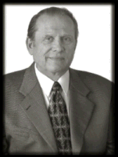
C:/BK6/DAVIDSON-DENBURG/Picture/herbert paperman.bmp

He married Leila WEINRAUCH, birth name Leah, married 25-Jun-1953 in Montreal, Quebec, CAN, (daughter of Joseph Gerald WEINRAUCH and Freda SMALL) b. 6-Feb-1931 in Montreal, Quebec, CAN.

a. Joseph Gerald PAPERMAN, b. 4-Apr-1954 in Montreal, Quebec, CAN, occupation Funeral Director at Paperman & Sons 3888 Rue Jean-Talon O, Mont-Royal, QC.
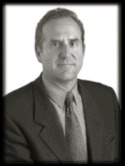
C:/BK6/DAVIDSON-DENBURG/Picture/joseph paperman.bmp

He married Heather RITZ, married 19-Jun-1980 in Montreal, Quebec, CAN, b. 16-Aug-1957 in Montreal, Quebec, CAN.

(1) Bram Alexander PAPERMAN, b. 10-May-1984 in Montreal, Quebec, CAN.

(2) Evan Stewart PAPERMAN, b. 31-Dec-1985 in Montreal, Quebec, CAN.

(3) Jason Bradley PAPERMAN, b. 17-Aug-1988 in Montreal, Quebec, CAN, education ?-Mar-2001 LCC Middle School toured England.

b. Laurence PAPERMAN, also known as Lazar (Yiddish) Elazar (Hebrew), b. 16-Jun-1956 in Montreal, Quebec, CAN, occupation Funeral Director at Paperman & Sons 3888 Rue Jean-Talon O, Mont-Royal, QC.
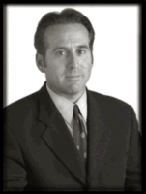
C:/BK6/DAVIDSON-DENBURG/Picture/lawrence paperman.bmp

He married Bonnie WISEBERG, married 18-Dec-1986 in Montreal, Quebec, CAN, b. 1-Apr-1959 in Montreal, Quebec, CAN.

(1) Noah Adam PAPERMAN, b. 2-Jun-1987 in Montreal, Quebec, CAN.

(2) Joshua Bryan PAPERMAN, b. 15-Feb-1989 in Montreal, Quebec, CAN.

c. Ross Neil PAPERMAN, b. 23-Dec-1958 in Montreal, Quebec, CAN, occupation Funeral Director at Paperman & Sons 3888 Rue Jean-Talon O, Mont-Royal, QC.
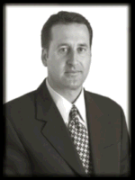
C:/BK6/DAVIDSON-DENBURG/Picture/ross paperman.bmp

He married Selena ALTRO, married 19-Jul-1986 in Montreal, Quebec, CAN, b. 25-Dec-1961 in Montreal, Quebec, CAN.

(1) Alexandra PAPERMAN, b. ?-Dec-1989 in Montreal, Quebec, CAN, event B’nai Tzedek-children of righteousness.

(2) Jared PAPERMAN.

C. Harry (Hirsch) SVERDLOVE, also known as Aryeih ben Nachum Sverdlov, (son of Louis (Nachum Leyb) SVERDLOVE and Sonia DAVIDSON) b. 17-May-1906 in Lepel', Vitebsk, Byelorussia, emigrated 16-May-1911 to Montreal, Canada from Lepel', naturalized in Canada as British subject, immigrated abt 1924 to Brooklyn, NY from Montreal. Enter U.S.A. at Rouses Point, NY, b. abt 1924 in with Aunt Rose Dickman, resided 1925 - 1934 at Buffalo Avenue, Brooklyn, NY, resided 1934 - 1939 at 167th Street, Washington Heights, New York, NY, d. 15-Dec-1966 in Mt. Vernon, Westchester, NY, resided 1939 - 1966 at 566 North Columbus Avenue, Mt. Vernon, NY, buried 1966 in Mt. Pleasant Cemetery, Valhalla, Westchester, NY.
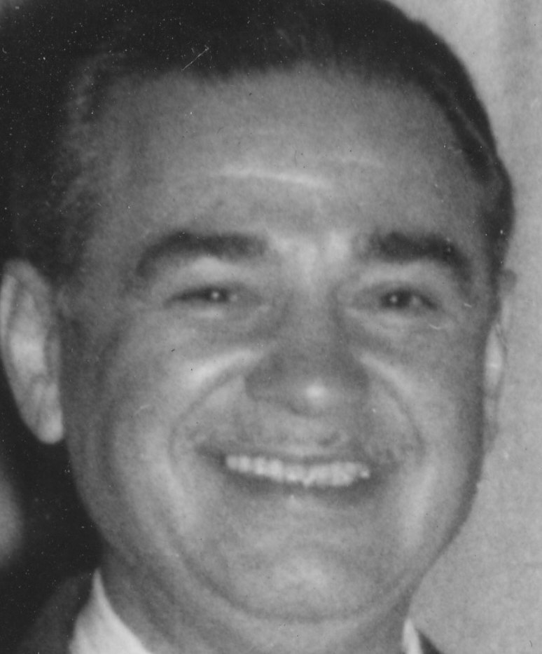
C:/BK6/DAVIDSON-DENBURG/Picture/Harry Sverdlove close-up about 1956.jpg

He married Lee Leah Ruth ROTHMAN, also known as Lei'ah Rasha, birth name Leah Rut, married 24-Dec-1934 in Manhattan, New York, NY, (daughter of Nathan ROTHMAN and Zelda (Zlate) DENBURG) b. 1-Sep-1912 in Montreal, Quebec, CAN, immigrated 1924 to Pittsburgh, PA (to aunt Rose Wiener's), resided abt 1924 - 1926 in Pittsburgh, PA, resided abt 1927 - 1930 in 245 9th Avenue, Roselle, NJ, graduated 1929 - 1931 from Roselle High School, resided 1931 - 1934 at 47 Barrett Street, Brooklyn, NY, occupation 1931 - 1934 buyer for Macy's, resided abt 1934 -1939 at 167th Street, Washington Heights, New York, NY, resided 1939 - 1961 at 566 North Columbus Avenue, Mt. Vernon, NY, d. 24-Mar-1961 in Mt. Vernon, Westchester, NY, buried ?-Mar-1961 in Mt. Pleasant Cemetery, Valhalla, Westchester, NY.
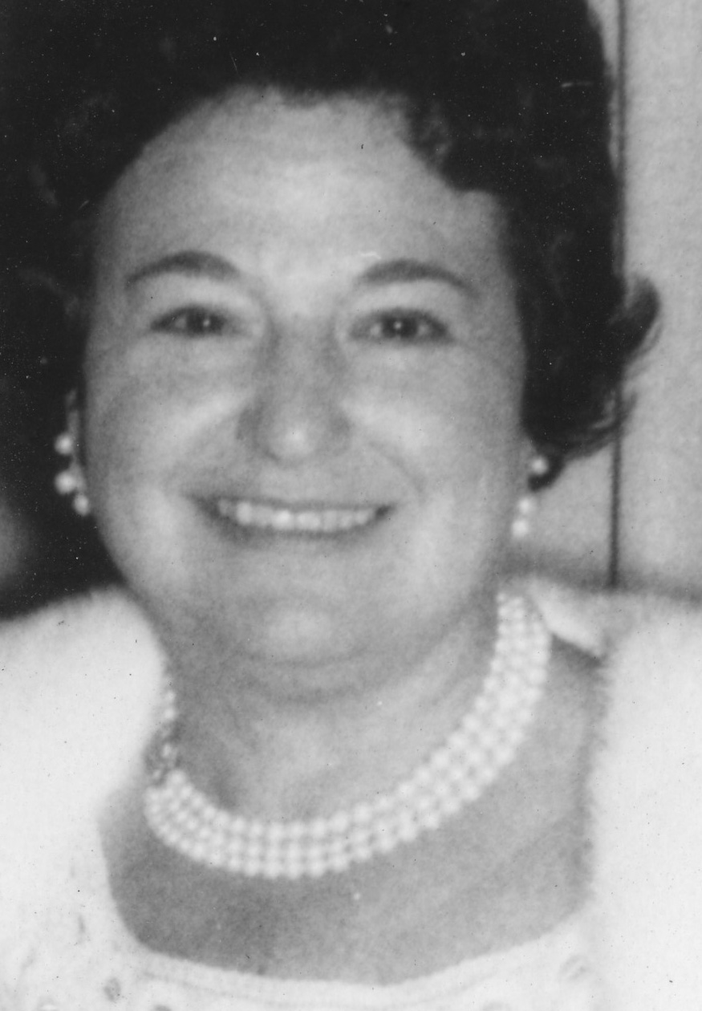
C:/BK6/DAVIDSON-DENBURG/Picture/Lee Sverdlove about 1956.jpg

1. Zolita Sue SVERDLOVE, also known as Zlota Zehave, b. 21-Feb-1936 in Bronx (Bronx Hospital), Bronx, NY, occupation artist-painter, resided 1936 - 1939 at 167th Street, Washington Heights, New York, NY, resided 1940 - 1960 at 566 N Columbus av, Mt. Vernon, NY, resided in Los Angeles, Los Angeles County, California, resided 1960 - 1964 at 675 Upland Rd., Redwood City, CA, resided 1965 - 1967 in New Rochelle, NY, resided 1968 - 1982 in Dallas TX, resided 1983 at 1445 Indiana Ave., South Pasadena, CA 91030, event Citations.

She married Donald RAPP, married 30-May-1956 in Mt. Vernon (Free Synagogue of Westchester), Westchester, NY, (son of Jacob RAPP formerly RAPPAPORT and Irene (Etta) LEVINSON) b. 27-Sep-1934 in Brooklyn, Kings, NY, occupation Ph.D.
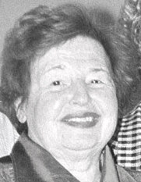
C:/BK6/DAVIDSON-DENBURG/Picture/Zolita Sverdlove Rapp (20000329) b&w.jpg

a. Erica Lee RAPP, also known as Lei'ah (Leah), b. 24-May-1961 in Palo Alto (Stanford Hosp), CA.

b. Melissa Harriet RAPP, b. 17-May-1967 in Stamford, Fairfield, CT, resided 1967 - 1977 in New Rochelle, NY, resided 1977 - 1980 in Dallas, Texas, resided 1972 - 1993 at 1445 Indiana Avenue, South Pasadena, California, resided at 8569 Burton Way, 404 Los Angeles, CA 900, immigrated in ->Dallas, TX->Pasadena, CA.
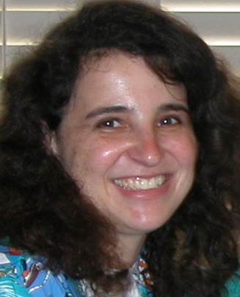
C:/BK6/DAVIDSON-DENBURG/Picture/Melissa Rapp 20030616 (#3).jpg

She married Joe REED, nickname Joey, married Jun 1993 in Irvine, CA, b. 21-Aug-1965 in Los Angeles, Los Angeles County, California, occupation therapist.
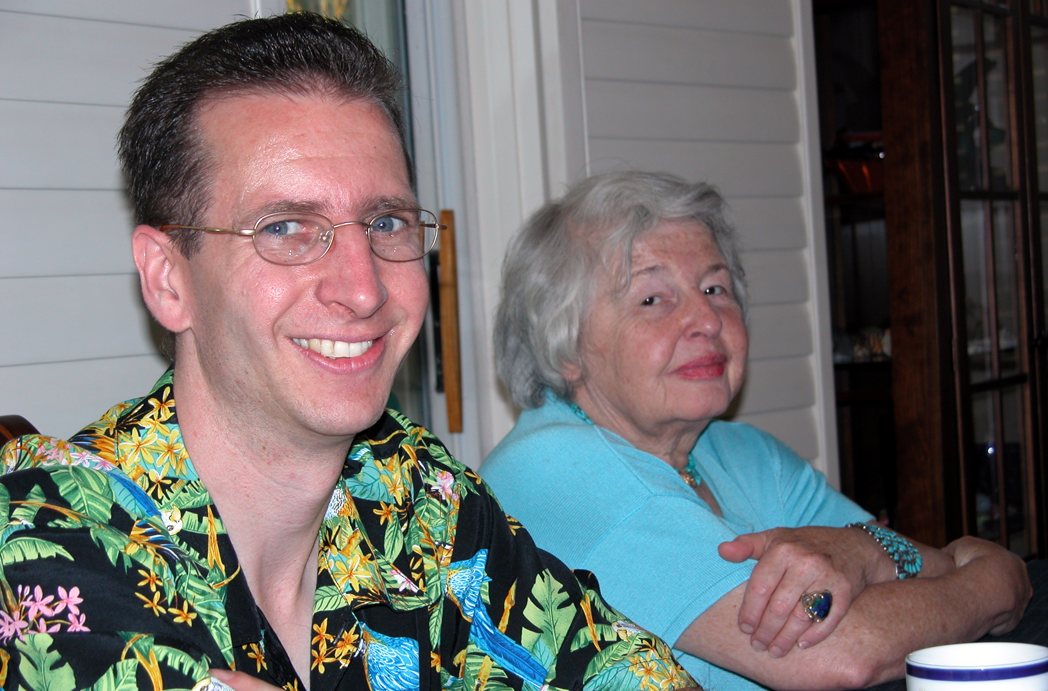
C:/BK6/DAVIDSON-DENBURG/Picture/joe&lita.jpg

(1) Sabrina REED, b. 7-Jul-1998.
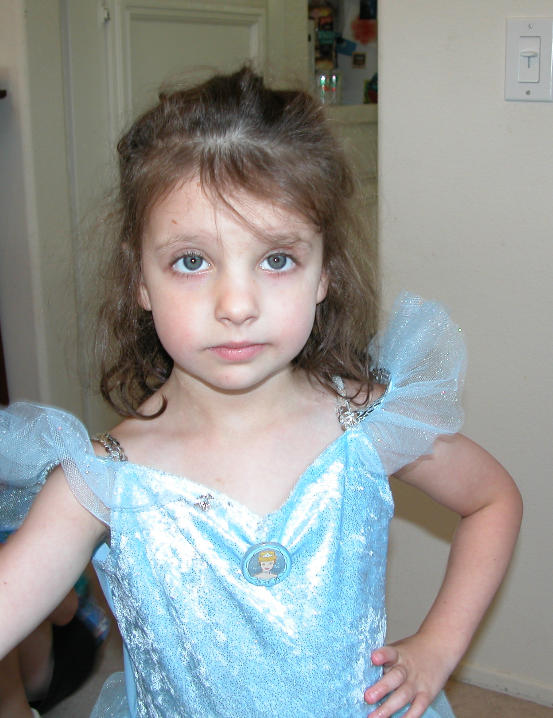
C:/BK6/DAVIDSON-DENBURG/Picture/Sabrina Reed 20030616 (#1).jpg

(2) Shannon REED, b. 2-Feb-2001 in Anaheim, Orange, CA.
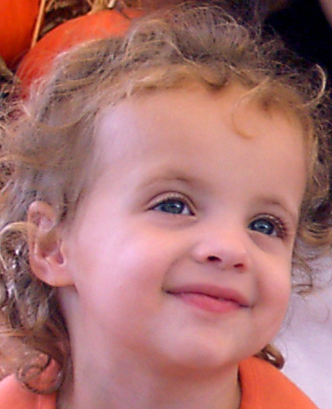
C:/BK6/DAVIDSON-DENBURG/Picture/Shannon Reed 20031020 (#2A).jpg

2. Andrew Ira SVERDLOVE, Hebrew name Chanokh (Enoch) ben Aryeih, also known as Andy, b. 29-Mar-1940 in The Bronx at The Bronx Hospital, Bronx, NY, resided 1940 - 1964 at 566 North Columbus Avenue, Mt. Vernon, NY, bar mitzvah ?-___-1953 at The Free Synagogue of Westchester, Mt. Vernon, NY, graduated 1957 from Cheshire Academy, Cheshire, CT, education class of '61 Renssaeler Polytechnic Institute, Troy, NY, graduated 1963 from New York University, Sterne School of Business, military 1964 - 1970 Army Reserves, event 1966 Master Electricians License #9493 New York City, event 1967 in NJ, State Master Electrician's License, occupation Electrical Construction, Quality Control, Field Engineer, resided 1975 at 333 East 49th Street, New York, NY, resided 1975 in furnished apartment, Mamaroneck, NY, resided 1975 - 1976 at Weaver Street, Larchmont, NY, resided 1976 at LeBeau apt. on East 72nd Street, New York, NY, resided 1976 on Fire Island for the summer, resided 1977 - 1978 in house then condo on Palmer Ave. with Judy Rosenberg, resided 1978 - 1979 at Albee Court, Larchmont Ave, Larchmont, NY with Jill & Harry, resided 1979 - 1984 at 32 Pine Ridge Road, Larchmont, NY, resided 1995 - 1997 at 79 North Broadway, White Plains, NY, resided 1998 - 2000 at 1 Franklin Avenue, White Plains, NY, resided 2004 on 6-month assigment in Wichita Falls, TX.
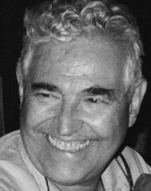
C:/BK6/DAVIDSON-DENBURG/Picture/Andrew Sverdlove 20030718 bw.jpg

He married (1) Adrienne Mae (Lipsky) LIPTON, Hebrew name Avrahamit Malka, birth name Adrienne Mae Lipsky, resided (family) 1964 - 1966 at 201 East 28th Streeet, New York, NY, resided (family) 1967 - 1973 at 566 North Columbus Avenue, Mt. Vernon, NY, resided (family) 1973 - 1974 at 12 Avon Road, Larchmont, NY, married 6-Dec-1964 in New Rochelle, Westchester, NY, divorced 1974, (daughter of Harry Lipsky now LIPTON and Dorothy HOFFMAN) b. 7-Nov-1940 in Bronx, Bronx, NY, graduated 1957 from Mamaroneck High School, Mamaroneck, NY, education 1957 - 1959 Syracuse University, graduated 1962 from Mills College, New York, NY, occupation 1963 - 1965 kindergarten Teacher, occupation 1962 - 1970 shoe model, resided 1974 - 1978 at 12 Avon Road, Larchmont, NY, occupation 1975 - 2004 Residential Realtor, resided 1978 - 1979 with mother in Harrison, NY, resided 1979 - 1982 at 46 Pine Ridge Road, Larchmont, NY, resided 1983 in Harrison, NY.
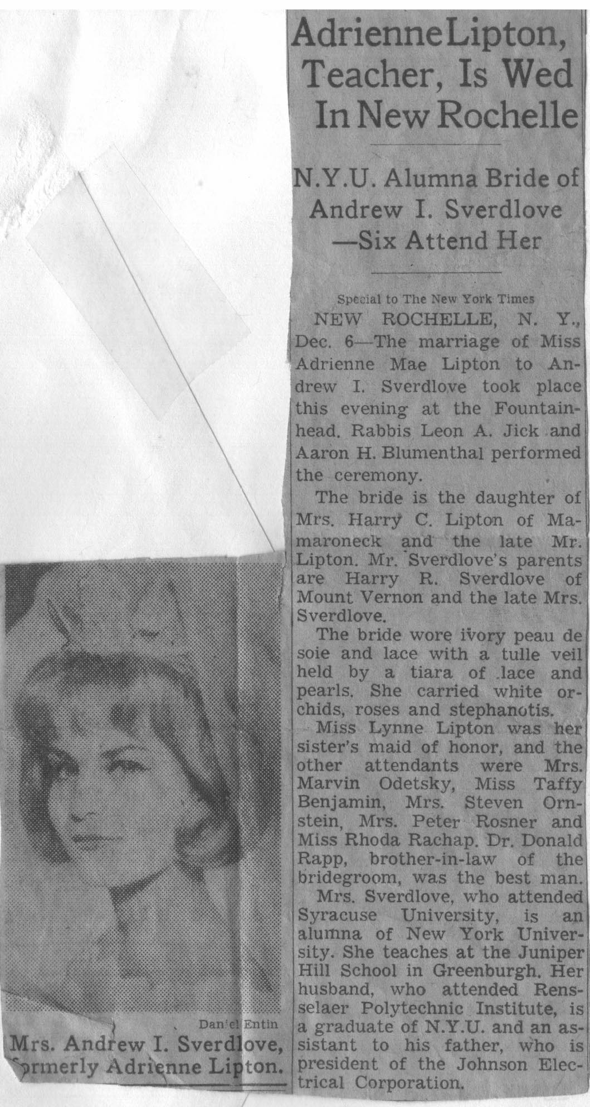
C:/BK6/DAVIDSON-DENBURG/Picture/71 Adrienne LIPTON wedding NYT.jpg

Partner Judy ROSENBERG, not married 1978.

He married (3) Linda Jean FRIEDMAN, resided (family) 1984 -1994 at 32 Pine Ridge Road, Larchmont, NY, married 21-Oct-1984 in Larchmont (Temple), Westchester, NY, divorced 1998, b. 30-Jan-1945 in Pittsburgh, Contra Costa, CA, (daughter of Alexander William FRIEDMAN and Violet Lily HUOPANA) immigrated in ->Dutchess Co, NY->Westchester Co, NY.

He married (4) Jane SIMON, resided (family) 1999 - 2004 at 145 Central Park West, 1A, New York, NY 10023, common law.

a. Lisa Sue SVERDLOVE, Hebrew name Leah Sarah, (daughter of Andrew Ira SVERDLOVE and Adrienne Mae (Lipsky) LIPTON) b. 10-Nov-1965 in Manhattan (Flower 5th), New York, NY, resided 1965 - 1966 at 201 East 28th Streeet, New York, NY, resided 1967 - 1973 at 566 North Columbus Avenue, Mt. Vernon, NY, resided 1973 - 1978 at 12 Avon Road, Larchmont, NY, resided 1979 - 1982 at 46 Ridge Road, Larchmont, NY, resided 1983 - 1987 in Harrison, NY, resided 1988 - 1994 in Louisville, KY, resided 1996-2004 at 729 Ridge Road, Harmony, NJ 08865, resided 2004- at 31 Goldfinch Lane, Neshanic Station, NJ 08853, education 1984 college classes in Westerchester County colleges, graduated 1985 from BS, Clark University, Worceser, MA, education 1986 -1987 Fordham University, Bronx, NY, graduated 1982 from Mamaroneck H.S., Mamaroneck, NY, graduated 1990 in MS Biology, University of Kentucky, Louisville, KY, occupation Teacher, Ag Extension Agent, occupation 1995 - 2004+ County 4-H Agent, Rutgers Cooperative Extension of Somerset County, 4-H Youth Development, Bridgewater, NJ 08807.
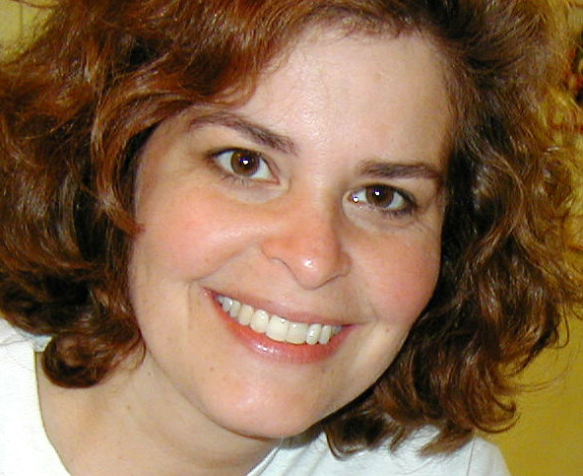
C:/BK6/DAVIDSON-DENBURG/Picture/Lisa Sue Sverdlove 20030521.jpg

She married Stephen Jude ROTHENBURGER, married 30-Dec-1990 at Wildwood Country Club, Louisville, Jefferson, KY,, (son of Vernon Douglas ROTHENBURGER and Sarah "Sally" Monica BAKER) b. 15-Sep-1965 in Baptist Hospital, Louisville, Jefferson, KY, occupation Ph.D research micro-biologist, graduated ?-Jun-1983 from St. Xavier High School, Louisville, KY,⁸ graduated 1987 from Duke University, Durham, North Carolina; BS,⁸ graduated 1992 from University of Louisville, Louisville, KY with a Ph.D.,⁸ occupation 1992 - 1993 Graduate teaching during Post Doctoral work,⁸ occupation 1993 - 1996 Exxon Reseach Facility in Clinton, NJ,⁸ education 1993 - 1996 Post Doctoral work for Mr. Ron Atlas under a grant from Exxon,⁸ resided 1994 - 2004 at 729 Ridge Road, Harmony Township, NJ, resided 2004 at 31 Goldfinch Lane, Neshanic Station, NJ 08853,⁸ event 1-Nov-2004 at Hyatt Regency, New Brunswick, NJ.
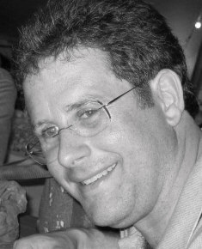
C:/BK6/DAVIDSON-DENBURG/Picture/Stephen Rothenburger 20030813 bw.jpg

(1) Noah Vernon ROTHENBURGER, b. 2-Nov-1999 in Hunterdon Regional Medical Center, Flemington, Hunterdon, NJ.
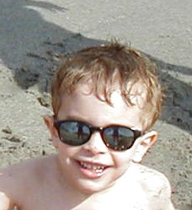
C:/BK6/DAVIDSON-DENBURG/Picture/Noah Rothenburger (Feb 2004).jpg

(2) Eliza Jeanne ROTHENBURGER, b. 14-Mar-2003 in Hunterdon Regional Medical Center, Flemington, Hunterdon, NJ.
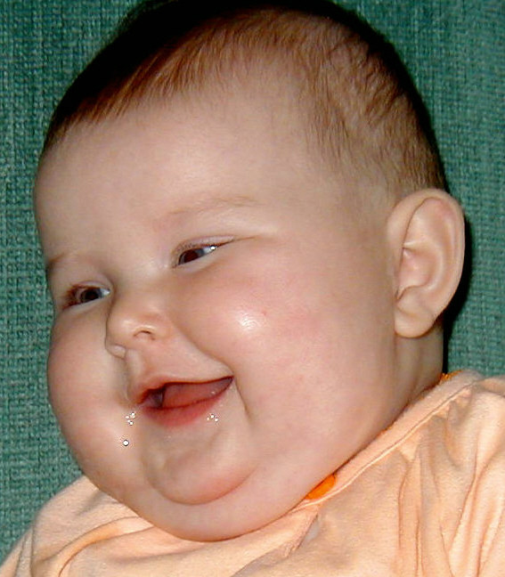
C:/BK6/DAVIDSON-DENBURG/Picture/Eliza Jeanne Rothenburger 20030723 color.jpg

b. Jill Louise SVERDLOVE, Hebrew name Zenia Yochana Leib, (daughter of Andrew Ira SVERDLOVE and Adrienne Mae (Lipsky) LIPTON) b. 24-Jul-1968 in Manhattan (University Hospital), New York, NY, resided 1968 - 1973 at 566 North Columbus Avenue, Mt. Vernon, NY, graduated 1985 from Mamaroneck High School, Mamaroneck, NJ, resided 1973 -1978 at 12 Avon Road, Larchmont, NY, resided 1978 - 1979 at Albee Court, Larchmont Ave, Larchmont, NY with father, resided 1979 - 1982 at 46 Pine Ridge Road, Larchmont, NY, resided 1981 - 1982 at 32 Pine Ridge Road, Larchmont, NY with father, resided 1983 - 1984 in Harrison, NY with mother, resided 1984 - 1985 in New Rochelle, NY with great Uncle Arthur, resided summer 1984 in Los Angeles, Los Angeles County, California, graduated 1989 from University of Pennsylvania, resided 1989 - 1992 in Louisville, CO, resided 1993 - 1995 in Hoboken, NJ, resided 1998 - 2003 on west 74th Street, New York, NY, resided 2003 in Virginia Beach, VA, resided 2004 in Colorado mountains, resided 2004 in Boulder, CO, occupation 1993 - 1997 baseball cap manufacturing company in Jersey City, NJ, occupation 1998 sales rep for a baseball cap manufacturing company, ordination 1999 - 2003 in New York, NY; Gotham Writers Workshop.
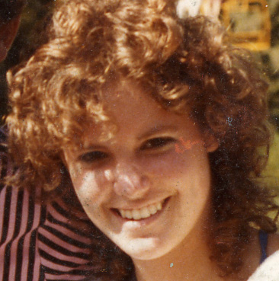
C:/BK6/DAVIDSON-DENBURG/Picture/Jill-15yo-1973.jpg

She married Mitch CAHN, married 4-Apr-1993 in Tarrytown (Marion Kirsch),Westchester, NY, divorced abt 1997, b. 20-Aug-1967 in NJ ?, occupation Manufacturer of Caps.

c. Harry Ross SVERDLOVE, Hebrew name Aryeih-Aharon ben Chanuch, (son of Andrew Ira SVERDLOVE and Adrienne Mae (Lipsky) LIPTON) b. 31-Jul-1969 in Manhattan (University Hospital), New York, NY, graduated 1985 from Mamaroneck High School, Mamaroneck, NJ, education 1985 - 1988 M.I.T., occupation Computer Software Engineer, resided 1969 - 1973 at 566 North Columbus Avenue, Mt. Vernon, NY, resided 1973 -1978 at 12 Avon Road, Larchmont, NY, resided 1978 -1979 at Albee Court, Larchmont Ave, Larchmont, NY with father, resided 1979 -1982 at 46 Pine Ridge Road, Larchmont, NY, resided 1989 - 1993 in Boston, MA, resided 1993 in MA, resided 1995 - 2004 at 4 Sherburne Lane, Westford, MA 01866-1178.
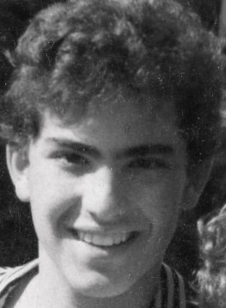
C:/BK6/DAVIDSON-DENBURG/Picture/Harry-14yo-1983 bw.jpg

He married Grace CENTRELLA, married 18-Feb-1995 in Malden (Immaculant Conception), Middlesex, MA, b. 13-Nov-1965 in Malden, Middlesex, MA, (daughter of Aquilino Gerald CENTRELLA and Aurelia "Lia" PETRILLO) occupation Executive Secretary, resided at 4 Sherburne Lane, Westford, MA 01866-1178.
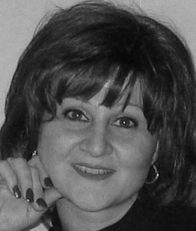
C:/BK6/DAVIDSON-DENBURG/Picture/Centrella Grace 20031128.jpg

(1) Michael Gerard SVERDLOVE, b. 21-Sep-1995 in Stoneham (BRMC), Middlesex, MA, resided 1995 at 4 Sherburne Lane, Westford, MA 01866-1178.
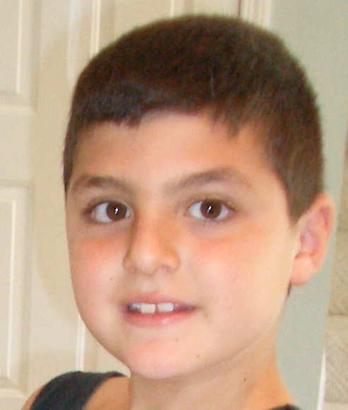
C:/BK6/DAVIDSON-DENBURG/Picture/Michael Gerald Sverdlove.jpg

(2) Rachael Devorah-Ann SVERDLOVE, b. 31-Jan-1997 in Stoneham (BRMC), Middlesex, MA, resided 1997 at 4 Sherburne Lane, Westford, MA 01866-1178.
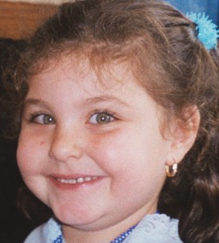
C:/BK6/DAVIDSON-DENBURG/Picture/Rachael Sverdlove 20021130.bmp

D. Jack (Yankel) SVERDLOVE, Hebrew name Ya'akov ben Nachum Aryeh, also known as Yankel, (son of Louis (Nachum Leyb) SVERDLOVE and Sonia DAVIDSON) b. 10-Jan-1907 in Lepel', Vitebsk, Byelorussia, immigrated abt 1909 - 1911 to Montreal, Canada from Lepel', naturalized in Canada as British subject, religion 1937 Beth Hamedrash Hagadol recorded birth with government,³ resided at 5180 Grand Street, Montreal, QC, CAN, d. 20-May-1987 in Montreal, Quebec, CAN, buried 22-May-1987 at Kehal Israel Cemetery, Dollard des Ormeaux , QC, Canada.

He married Gabrielle (Mrs.) SVERDLOVE, married 24-Jun-1947 in Montreal, Quebec, CAN, b. 1-Mar-1915 in Quebec, Canada, resided at 5180 Grand Avenue, Montreal, Canada, d. 21-Oct-2002 in Montreal, Quebec, CAN, buried at Kehal Israel Cemetery, Dollard des Ormeaux , QC, Canada.

1. Myra SVERDLOVE, b. 18-Feb-1949 in Montreal, Quebec, CAN, resided 1949 - 1970 at 5180 Grand Street, Montreal,, resided 1972 - 2004+ at 166 Butternut Crescent, Dollard-des-Ormeaux, QC H9A 2A8.

She married Norman M. BROODNEY, married 1969 at Queen Elizabeth Hotel, Montreal, Quebec, CAN, (son of Harry BROODNEY and Sylvia LEVENSTONE) b. 16-Apr-1947 in Montreal, Quebec, CAN, occupation General Contractor.

a. Jeffrey Adam BROODNEY, b. 26-Feb-1976 in Montreal, Quebec, CAN, resided 1976 - 1997 at 166 Butternut Crescent, Dollard-des-Ormeaux, QC H9A 2A8, education 1994 - 1996 Concordia University, resided 2001 -2004 in Ottaw, ON, occupation 2001 - 2004 group home for young offenders in Ottaw.

Partner Lisa SIMS, not married b. abt 1977.

2. Alan SVERDLOVE, also known as Chanokh ben Ya'akov, b. 21-Feb-1951 in Montreal, Quebec, CAN, resided 1951 - 1974 at 5180 Grand Street, Montreal,, resided 1990 at 85 Thorncliffe Park Drive, Toronto, Ontario, resided 2000 - 2004+ at 17743 Rue Gowdridge, Pierrefonds, PQ H9J 3L5.

He married (1) Hugette (Mrs.Alan) SVERDLOVE, married abt 1974 in Montreal, Quebec, CAN, divorced 1994, b. abt 1953 in Canada.

He married (2) Bonnie THAU, occupation surgical nurse at the Royal Vic Hospital.

a. Jake SVERDLOVE, (son of Alan SVERDLOVE and Bonnie THAU) b. 26-Jan-1994.

b. Alexa SVERDLOVE, (daughter of Alan SVERDLOVE and Bonnie THAU) b. 8-Nov-1996.

CITATION: Jewish Data, Center for Jewish History , On-line Database www.jewishdata.com/secure/.
Passport , Sonja Swerdlow, a.k.a. Sonia Sverdlova on 16-May-1911 traveling with kinder (infants): Hirsch, Jankel, Risia, und (et) Sora-Gene.
Jewish Genealogical Society of Montreal, Jewish vital records of Montreal. Quebec, Canada; 1841 - 1942.
New York City records K1758.
RESI: http://www.switchboard.com/.
Jewish Genealogical Society of Montreal, Jewish vital records of Montreal. Quebec, Canada; 1841 - 1942, Svedlove, Rose & Paperman, Abraham; Beth David 1923.
Ancestry.com, Biography & Genealogy Master Index ([database online]. Provo, UT: MyFamily.com, Inc., 2003), Gale Research Company. Biography and Genealogy Master Index. Detroit: Gale Research Co., 2003. Name: Sverdlove, Zolita Birth - Death: 1936- Accession Number: 4276466 Source Citation: The Printworld Directory of Contemporary Prints & Prices. 1983/84, second edition. Edited by Selma Smith. Bala Cynwyd, PA: Printworld, 1983. Not in strict alphabetical order. (PrintW 2) The Printworld Directory of Contemporary Prints & Prices. 1985/86, third edition. Edited by Selma Smith. Bala Cynwyd, PA: Printworld, 1985. Not in strict alphabetical order. (PrintW 3) Who's Who in American Art. 14th edition. New York: R.R. Bowker, 1980. (WhoAmA 14) Who's Who in American Art. 15th edition. New York: R.R. Bowker, 1982. (WhoAmA 15) Who's Who in American Art. 16th edition. New York: R.R. Bowker, 1984. (WhoAmA 16) Who's Who in American Art. 17th edition. New York: R.R. Bowker, 1986. (WhoAmA 17) Who's Who in American Art. 18th edition, 1989-1990. New York: R.R. Bowker, 1989. (WhoAmA 18) Who's Who in American Art. 19th edition, 1991-1992. New Providence, NJ: R.R. Bowker, 1990. (WhoAmA 19) Who's Who in American Art. 20th edition, 1993-1994. New Providence, NJ: R.R. Bowker, 1993. (WhoAmA 20) Who's Who in American Art(R) (Marquis(TM)). 23rd edition, 1999-2000. New Providence, NJ: Marquis Who's Who, 1999. (WhoAmA 23) Who's Who of American Women. 16th edition, 1989-1990. Wilmette, IL: Marquis Who's Who, 1988. (WhoAmW 16).
BIOGRAPHY: Interview; Rothenburger, Sally; 31-Oct-2004, Interview by Andrew Ira Sverdlove.
Commonwealth of Kentucky, Office of Vital Statistics, KENTUCKY MARRIAGE INDEX FOR 1973-1993 , [database online] University of Kentucky (http://ukcc.uky.edu/~vitalrec/), The vital records index data was obtained from the Kentucky Office of Vital Statistics in 1994 for a research project. Groom: STEPHEN J ROTHENBURGER ; G-race White; G-residence Jefferson County; Bride LISA S SVERDLOVE; B-race White; B-residence Jefferson County; Date 123090 Place Jefferson County; License Jefferson County. RESEARCHER-UPDATE: Andrew I. Sverdlove, 12-Jan-2005; Source Documentation.
Ted Torphy and the Council of Research Directors, Johnson Medal for Research & Development, 2004 , Johnson & Johnson, Corporate Office of Science & Technology, 10-Sep-2004.
mother.

